5-2 Coding Assignment: Certificate Generation

Cristiano Miranda
Southern New Hampshire University
CS-305: Software Security
Professor Berdik
30 November 2025

5-2 Coding Assignment: Certificate Generation
Security is a key focus in application development, as the data sent to, received from, and generated by users is arguably the most important part of any application. Even if a project is created in a way that ensures no vulnerabilities exist within the application, failing to account for elements outside the application can leave users vulnerable and potentially compromise their safety. For instance, even if an application has the necessary methods to connect to users' devices securely, users can still be compromised if the application fails to connect to the server securely.
There are multiple methods for a hacker to hijack a user's session, such as spoofing and URL redirection attacks, that can redirect a user to a false site masquerading as the original website created by a company. Thus, to ensure that users are aware and able to confirm that the site they access is legitimate and trustworthy, a certificate can be generated to validate the server's identity. However, allowing any site to create and validate these certificates would negate their purpose, as anyone could falsify their identities without an authority to verify them. Thus, a Certificate Authority (CA) is used to both generate and verify the certificates that sites use. Sites can request certificates to verify their identities before the CAs direct users to their sites. From here, any user who wishes to connect to the site first connects to the CA and provides the site they wish to reach. The CA then requires the site to provide a valid certificate that proves the site's identity before the user is connected. As Dean Coclin states in his work, Certificate Authorities validate these certificates for sites, which allows for "encryption between web browsers and servers. This encryption ensures that any data exchanged… remains private and secure" (Coclin, 2021). Having a third party verify the site's identity prevents users from being compromised by external factors before they reach the site, as they can be assured they will not be redirected to a masquerading site that could steal their data or compromise their system, and that once they do reach the site, their data is secured and encrypted.
Using a CA to validate a site externally can help ensure user safety and security before they establish a connection to a site. CAs help ensure that users connect to the correct site before establishing a connection, preventing malicious data or users from gaining access to the user's connection. Again, as Dean Coclin states in his work, without the use of Certificate Authorities, there would be no "reliable way to verify whether a website is genuine or a phishing attempt" (Coclin, 2021). CAs help ensure that users connect to the correct site and that their data is not sent to a malicious source that could compromise them. Mainly, implementing CAs adds an extra security layer for users, as it verifies the site's identity before they connect, helping prevent them from sending data to a malicious user.
Having the CAs as the first point of contact ensures that users are not at risk before connecting to the site. Even if a malicious site masquerades as the official site and a user attempts to connect to it, CAs will prevent the connection between the user and the malicious server, protecting the user from potentially interacting with the malicious site and compromising their safety. Overall, CAs are important in ensuring that users can verify the identities of sites and avoid navigating to masquerading sites that could compromise their security.

Certificate File Generation:
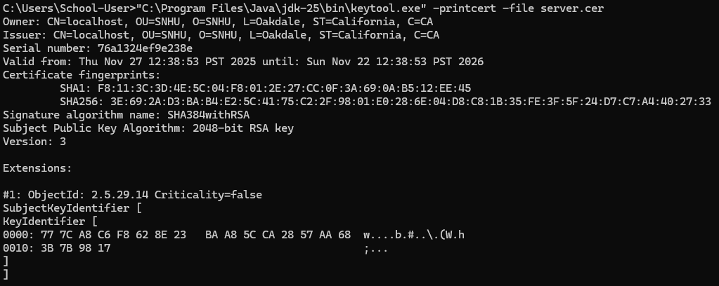
Certificate File Saved:

References
Coclin, D. (2021, June 26). What Is a Certificate Authority? | CA’s Explained | DigiCert.
Www.digicert.com. https://www.digicert.com/blog/what-is-a-certificate-authority

